


Brettenham Primary School
Allergy Safety Policy

Last Reviewed: | September 2026
Date Reviewed: | September 2026
Reviewed by: | Executive Team
Next Review: | September 2027

The review date is a guide and the policy remains in place until such time as it has been reviewed or superseded by updated relevant statutory guidance.

This policy is in line with DfE ‘supporting pupils at school with medical conditions’ (Statutory Guidance) December 2015

Contents
Page
1. Policy Statement 3-4
2. Equalities Statement 4
3. Principles 5
4. Allergy Management Checklist 5
5. Roles and Responsibilities 6-11
6. Supply, Storage and Care of Medication 11-13
7. Catering 13-15
8. Emergency Treatment & Management of Anaphylaxis 15-16
9. Minimising Risk and Awareness of Allergens 16-17
10. Risk Assessments 17-18
11. Training and Awareness 18-19
12. Identification of Individuals with Allergies 19-20
13. Individual Healthcare Planning 20-21
14. School Trips & External Visits 21-22
15. Serious Incidents and New Misses 22-23
16. Wellbeing and Support 23
17. Safeguarding 23-24
18. Policy Monitoring and Review 24-25

Appendix I 26
Appendix II 27-28
Appendix III 29
Appendix IV 30
Appendix V 31
Appendix VI 32
Appendix VII 33
Appendix VIII 34-36

- Policy Statement

Brettenham School is committed to safeguarding the health, wellbeing and inclusion of all children. In accordance with the principles underpinning Benedict's Law, the school will maintain robust allergy management arrangements, promote awareness of allergy-related risks, ensure staff are appropriately trained, and implement effective procedures to prevent, recognise and respond to allergic reactions and anaphylaxis. We believe that every child has the right to learn, thrive and participate fully in school activities within a safe and supportive environment.

This policy should be read alongside the school’s Supporting Pupils with Medical Conditions Policy, Safeguarding Policy, Health and Safety Policy, First Aid Policy, Educational Visits Policy, Equality Policy and Attendance Policy.

Brettenham School recognises that allergic reactions, including anaphylaxis, can be serious and potentially life-threatening. We are committed to implementing effective arrangements for allergy prevention, risk reduction, emergency response and the promotion of wellbeing for individuals living with allergies.

This policy establishes the School’s arrangements for:

- Identifying individuals with allergies;
- Reducing exposure to allergens;
- Supporting pupils with medical needs;
- Ensuring effective communication between parents, staff and healthcare professionals;
- Providing appropriate training for staff; and
- Responding effectively to allergic reactions and anaphylaxis.

All schools within the Children First Academy Trust will take reasonable and proportionate steps to minimise risks whilst ensuring that pupils with allergies are able to participate fully in all aspects of school life.

Allergy safety is everyone’s responsibility and relies upon effective communication between pupils, staff, caterers and healthcare professionals.

Section 34 of the Children’s Wellbeing and Schools Act 2026 requires that LA maintained schools, academies and PRUs must have an allergy safety policy.

Under Section 100 of the Children and Families Act 2014, schools have a duty to support pupils at their school with medical conditions.

Brettenham School will comply with all statutory requirements relating to allergy safety, including maintaining a written Allergy Safety Policy, maintaining individual healthcare plans where required, ensuring staff training, and holding spare Adrenaline Auto-Injectors (AAIs) in accordance with current legislation.

The Allergy Safety Policy will be reviewed annually but can be reviewed more frequently, particularly where incidents or ‘near misses’ suggest areas for improvement. Any review will take account of any incidents and ‘near misses’ and seek to learn lessons from them.

The Trustees of Brettenham School will ensure that the policy is readily accessible to parents and staff. The Allergy Safety Policy will be published on the School’s website and a hard copy will be available on request.

Allergy is a spectrum of different allergic diseases. Reactions occur when a susceptible person is exposed to something (an ‘allergen’) they are allergic to. Asthma, food allergy, eczema and seasonal rhinitis (hay fever) are all forms of allergy.

Anaphylaxis can occur without any other signs (such as a skin rash) being present. Always consider anaphylaxis in someone with a known food allergy who has sudden difficulty in breathing. Giving adrenaline in this context is very safe and may be lifesaving.

The most common causes of ‘whole body’ allergic reactions – including anaphylaxis – are:

- foods e.g. peanuts, tree nuts, cow’s milk/dairy foods, egg, wheat, fish/shellfish and sesame;
- insect stings e.g. bee, wasps;
- medication e.g. antibiotics, pain medicines such as ibuprofen;
- latex e.g. rubber gloves, balloons, swimming caps.

Even for food allergies, the vast majority of anaphylaxis reactions require the
person to have eaten the food, although less serious allergic reactions can
happen through skin or other contact. Anaphylaxis reactions due to skin
contact is very rare. Students who have a skin reaction need monitoring for
at least an hour.

- Equalities Statement

Brettenham School understands that severe allergies are included in the Equality Act 2010. The act considers a person disabled if they have a physical or mental impairment that has a substantial and long-term negative effect on their ability to carry out normal daily activities. Seasonal rhinitis such as hay fever is explicitly excluded from the definition of disability, unless it aggravates the effect of another health condition.

Our School is clear about the need to actively support pupils with medical conditions to participate in school life.

Brettenham School will make reasonable adjustments where required in accordance with the Equality Act 2010.

Risk Assessments will be undertaken in accordance with Section 10.

- Principles

- To comply with all relevant health, safety, food information, equality, safeguarding and allergy-related legislation, regulations and statutory requirements.

- To encourage proactive steps to keep pupils safe.

- To ensure pupils from diverse backgrounds, ethnicities or different cultural heritages are not disadvantaged when dealing with allergies and food labelling.

- To work with the catering provider to establish a robust process and documentation for menu planning, food labelling, storing, avoidance of cross-contamination, stock ordering of food/drink used at the school.

- To provide an effective staff awareness programme on food allergies and intolerances, possible symptoms (anaphylaxis) recognition and actions to take.

- Allergy Management Checklist

- Does the child have an Individual Healthcare Plan
- Does your school hold the required number of spare Adrenaline Auto-Injectors (AAIs) which are accessible and regularly checked?
- Does each child have a completed and signed Allergy Action Plan?
- Have ALL school staff been trained in allergy and anaphylaxis?
- Does the school allergy policy include where and how to store AAIs?
- Is there a schedule to check the expiry dates on spare AAI’s and each child’s AAI?
- Does the school allergy policy cover catering for children with allergies?
- Does the allergy policy include pupil allergy awareness?
- Has the school completed an allergy risk assessment?
- Does the allergy policy include risk assessment of extra curricula activities?
- Does the allergy policy cover safeguarding children with allergies, including bullying?

- Roles and Responsibilities

Practical Steps (see also Appendix I & Appendix II)

In order to put these principles into practice we will:

Governors/Trustees

Governors and Trustees are responsible for ensuring that:

- Brettenham School has effective arrangements in place to support pupils and staff with allergies.
- The Allergy Policy is reviewed annually and remains compliant with current legislation and guidance.
- Appropriate resources are available to implement this policy effectively.
- Allergy safety is monitored through regular reports from school leaders, including significant incidents, training compliance and policy developments.
- Allergy management forms part of the School’s wider safeguarding, health and safety and wellbeing arrangements.
- Ensure adequate resources for the management of allergies are available.
- Ensure appropriate material is available on the school website for parent/carers highlighting how the school is managing pupils with allergies.
- Monitor the effectiveness of this Policy to ensure it remains fit for purpose.

The Headteacher will report annually to Governors on:

- Number of pupils with allergies.
- AAI usage.
- Near misses.
- Training compliance.
- Catering compliance.
- Policy review outcomes.

Headteacher

The Headteacher is responsible for ensuring that:

- This policy is implemented consistently across the school.

- Appropriate systems are in place to identify pupils with allergies and communicate relevant information to staff.

- Individual Health care Plans (IHPs) and Allergy Action Plans (AAPs) are maintained where required.

- Staff receive appropriate allergy awareness and anaphylaxis training.

- Emergency procedures are in place and understood by staff.

- Risk assessments are completed for activities where allergen exposure may occur.
- Parents/carers, healthcare professionals and catering providers are involved in supporting pupils with allergies.

- Allergy incidents, near misses and the use of AAIs are recorded, investigated and reviewed.

- Provide, as far as practicable, a safe and healthy environment in which people at risk of allergic reaction and anaphylaxis can participate equally in all aspects of school life and are not subject to bullying because of their condition.

- Ensure all visitors, volunteers, work experience students, sub-contractors are made aware of the school’s commitment to allergy management as part of Safeguarding.

- Ensure the school sends a copy of the medical details it holds for the child to parents/carers for review and update at the end of each school year. Seek updated medical information at the commencement of each calendar year and for any pupil joining in year.

- Ensure effective communication of individual pupil medical needs to all staff and that they know how and where to check for updated information.

- Ensure there are enough trained staff to meet the statutory requirements and assessed needs, allowing for staff absences away from the school premises.

- Ensure First Aid staff training includes allergy awareness, anaphylaxis recognition, AAI administration and emergency response procedures.

- Ensure best practice in the labelling of foodstuffs and their contents.

- Report to the Board of Governors/Trustees regarding the management of allergies within the School.

Allergy Lead/Designated Medical Lead

Each school will appoint a named member of the Senior Leadership Team as the Allergy Lead

The designated Allergy Lead/Medical Lead is responsible for:

- Maintaining an accurate register of pupils with allergies.

- Ensuring allergy information is shared appropriately with staff and catering teams.
- Coordinating the development and review of IHPs.

- Monitoring the storage, accessibility and expiry dates of medication, including spare AAIs.

- Maintaining records of training, incidents and near misses.

- Acting as the key point of contact for parents/carers and external professionals regarding allergy management.

- Supporting staff in implementing allergy-related procedures and risk assessments.

- Follow all legal requirements, recommended best practice and whole school procedures pertaining to allergies within the school context.

- Report to the Headteacher regarding pupils with allergies.

- Lead on the training of staff regarding allergy medical needs and their identification and management.

- Work closely with in-house and sub-contracted Catering Managers and Chef Managers in assisting in the support of pupils with known allergies (including meeting with parents/carers where requested) to discuss any special requirements.

- Ensure all copies of the AAP/IHP located around the school and/or on IT systems are identical if an updated version is received.

- Where an AAP has not been received for a pupil with recognised allergies, or if the medication information is not clear, liaise with GP/School Nursing Team, to obtain an up-to-date copy and/or clarification.

- Be trained in the use of an Adrenaline Auto-Injector (AAI) and be competent in performing any possible required prescribed medical treatment as outlined in the pupil’s IHP and/or AAP.

- Ensure all school trips, excursions or off-site extra curricula activities for pupils are pre-checked so that ‘safe’ food is provided or that an effective control is in place to minimise risk of exposure for pupils with allergies.

- Ensure spare AAI arrangements comply with Section 6 of this policy.

- Arrange for the correct disposal of out-of-date AAIs.

- Where anaphylaxis is suspected in an undiagnosed individual, call the emergency services and state ANAPHYLAXIS is suspected, then follow their advice as to whether administration of a spare AAI is appropriate.

- Ensure that, if a pupil notifies school that they are no longer allergic to a food, this information is checked prior to updating records and the IHP. (if applicable)

All Staff

All staff are responsible for:

- Following this policy and any individual healthcare arrangements relevant to pupils in their care.

- Complete statutory anaphylaxis training on an annual basis and be confident to respond to an allergy emergency.

- Recognising the signs and symptoms of allergic reactions and anaphylaxis.

- Taking immediate action in accordance with emergency procedures.

- Promoting an inclusive, allergy-aware environment.

- Following risk assessments and agreed control measures during lessons, visits and school activities.

- Reporting allergy-related incidents, concerns and near misses promptly.

- Follow as directed all the requirements of the school, including all legal requirements, recommended best practice and whole school procedures pertaining to allergies within the school context.

- Highlight the need for anti-bullying of pupils with the condition.

- Be aware of the pupils in your care (including regular cover classes) who have known allergies as an allergic reaction could occur at any time, not just at breaks or mealtimes.

- Any food-related activities must be planned, risk assessed and supervised in accordance with this policy.
.
Parents/Carers

Parents and carers are responsible for:

- Informing the school of any allergy, medical diagnosis or changes to treatment.

- Providing up-to-date medication and ensuring it remains within its expiry date.

- Providing an Allergy Action Plan and supporting the development of an Individual Health care Plan where required.

- Ensuring contact details are kept up to date.

- Supporting their child to develop age-appropriate allergy awareness and self-management skills.

- Informing the school of any allergic reactions or significant changes occurring outside school.

- Contribute to the provision of an IHP in partnership with the school, and relevant healthcare professional, where required.

- Provide any other written medical documentation, instructions and medications as directed by a health professional.

- If you require it, meet with the catering manager to discuss any specific requirements relating to your child’s allergy (information from these meetings will be recorded by the catering manager.)

- Be aware of the school Allergy Safety Policy and any arrangements for managing children with allergies and at risk of anaphylaxis.

- Communicate regularly with the school to support our ability to keep our children safe and act immediately in the event of an allergic reaction.

- Providing appropriate foods to be consumed by the child, if necessary, i.e. home packed lunch.

- Replace medications after use or upon expiry. Liaising with the school medical staff.

- Review the Policy and procedures with the school’s Headteacher and/or Member of Staff responsible for medical needs, the pupil’s GP and the pupil (if age appropriate) after a reaction has occurred.

Pupil with allergies (as age appropriate)

Where age and understanding permit, pupils are encouraged to:

- Take an active role in managing their allergy safely.

- Follow medical advice and school procedures relating to their allergy.

- Avoid sharing food, drinks, utensils or medication.

- Know how to access their medication and seek help if symptoms develop.

- Avoid eating anything with unknown ingredients.

- Know where their medication is kept and (if age appropriate and confident enough to administer their own auto-injectors) take responsibility for carrying AAIs on their person at all times.

- As soon as they suspect they are experiencing signs of allergic reaction tell an adult.

Catering Staff and Providers

Catering staff are responsible for:

- Maintaining accurate allergen information for all meals.

- Following food safety and allergen management procedures.

- Taking reasonable steps to prevent allergen cross-contamination.

- Working closely with the school and parents/carers to provide safe meal options where required.

- Undertaking allergen awareness training appropriate to their role.

- Following agreed identification process to ensure meals are provided to the correct pupil.

- Supply, Storage and Care of Medication

People at risk of anaphylaxis are prescribed two adrenaline devices which they should carry with them at all times. This includes the journey to and from;

- School
- The classroom
- Lunch area
- Playground
- Sports field
- When on visits or trips

All emergency medication must be readily accessible, clearly identified and
known to relevant staff at all times.

Depending on their level of understanding and competence, pupils will be
encouraged to take responsibility for and to carry their own AAI’s on
them at all times (in a suitable bag-container).

For younger children or those not ready to take responsibility for their own medication, there should be an anaphylaxis kit which is kept safety.

Serious anaphylaxis is a time critical situation; delays in administering adrenaline have been associated with fatal reactions. An adrenaline device needs to be administered within 5 minutes so if the adrenaline device cannot be with them in the classroom, the adrenaline device should be stored in an appropriate central location.

Brettenham School ensures all staff are aware of where AAIs are kept in school including emergency AAI’s.
Medication should be stored in a suitable container and clearly labelled with the pupil’s name. The pupil’s medication storage container should contain:

- Two AAI’s i.e. EpiPen or Jext

- An up-to-date allergy action plan

- Antihistamine as tablets or syrup (if included on allergy action plan)

- Spoon if required

- Asthma inhaler (if included on allergy action plan)

It is the responsibility of the child’s parents/carers to ensure that the
anaphylaxis kit is up-to-date and clearly labelled, however the School Welfare
Officer will check medication kept at school on a termly basis and send a reminder to
parents/carers if medication is approaching expiry.

Parents/Carers can subscribe to expiry alerts for the relevant AAI’s their child
is prescribed, to make sure they can get replacement devices in good time.

Older children and medication

Older children and teenagers should, wherever possible, assume responsibility for their emergency kit under the guidance of their parents. However, symptoms of anaphylaxis can come on very suddenly, so school staff need to be prepared to administer medication if the young person cannot.

Storage and Disposal

AAI’s must be stored at room temperature (in line with manufacturer’s guidelines), and not be exposed to extremes of heat. They should not be refrigerated or left in direct sunlight.

AAIs are single use only and must be disposed of as sharps. Used AAIs can be given to ambulance paramedics on arrival or can be disposed of in a pre-ordered sharps bin. Sharps bins to be obtained from and disposed of by the Local Authority clinical waste team.
Medical Room
The sharps bin is kept in the following room:

Spare AAIs

The Human Medicines (Amendment) Regulations 2017 permit ‘spare’ adrenaline devices to be used for the purpose of saving a life. This might be, for example, a child presenting for the first time with anaphylaxis due to an undiagnosed allergy.

Schools must maintain appropriately located and accessible spare AAIs in accordance with statutory requirements and manufacturer guidance. Immediate access to an AAI can be life-saving. Whilst it’s vital that families have their own prescribed AAIs for their child, having spare AAIs at school adds an extra layer of reassurance for everyone involved. It’s a step towards creating a safer and more inclusive environment for children managing severe allergies.

All Children First Academy schools hold spare adrenaline (AAIs) for use in emergency situations. These are not a replacement for pupil’s own adrenaline devices. Pupils prescribed adrenaline are expected to have their own adrenaline devices with them at school for use in an emergency.

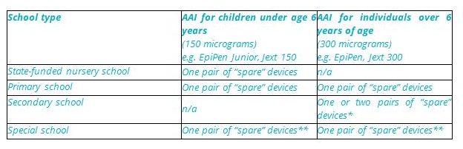
Brettenham School holds an emergency kit containing:
(2 x 150mcg Epipens)
(2 x 300mcg Epipens)
(And an emergency pouch for school trips containing 4 x 300mcg Epipens)

These are located in:
Emergency Kit - The School Office
Emergency pouch - The Medical Room.

The emergency kit is stored in a clear coloured container the emergency pouch is in a green pouch, both are labelled ‘Emergency Anaphylaxis Kit’.

The school medical welfare officer is responsible for checking that adrenaline devices are in date and remain clear (not cloudy) on a monthly basis. They will secure replacements one month before the current adrenaline device expires.

- Catering

- Maintain accurate allergen information.

- Ensure pupils with allergies can access safe meal options.

- Maintain clear systems to identify pupils requiring special dietary provision.

- Work closely with parents/carers regarding individual dietary requirements.

- All food businesses (including school caterers) must follow the Food Information Regulations 2014 which states that allergen information relating to the ‘The 14’ regulated allergens must be available for all food products.

- Schools must provide up-to-date allergen information to caterers immediately upon notification and whenever changes occur.

- Catering staff must maintain documented allergen information, undertake allergen awareness training and follow procedures to minimise cross-contamination.

- Students with allergies are identified at the point of service by wearing allergy warning badges and wristbands. A photograph of each child is also displayed on the allergy board in the kitchen to support clear and accurate visual identification. All allergen foods are prepared separately and plated onto red plates for easy identification.

- Ensure that food is always labelled as unlabelled food poses a potentially great risk of allergen exposure than packaged food with precautionary ‘may contain’ labelling suggesting a risk of contamination with allergen. This applies to foods used within the classroom curriculum e.g. cooking as well as that from the school kitchen.

- Teach pupils not to share food, drinks, utensils or containers with the reasons why.

- When staff provide food for the students, they received additional training to ensure they understand how to read labels for food allergens and how to prevent cross-contamination during the handling, preparation and serving of food.

- Where food is not directly provided by the school/catering company for example brought in as treats or to celebrate birthdays parent/carer permission will be sought in advance to ensure inclusion and safety for pupils with allergies.

- These procedures apply to school led breakfast and after school provision. Where this is provided by a third party, Brettenham School, will ensure that this policy is shared and the third-party provider meets the same procedures.

- Ensure that PTA events, follow FSA Food Standards Agency legislation for food labelling, creating allergen matrices as necessary. Ensuring that PTA members who are serving food have a basic awareness of allergen management. (Signpost them to free FSA training)

- Students eligible for benefits based Free School Meals are entitled to their free school meal entitlement. School will work with parents/carers to determine the best way of ensuring that students receive their meal.

The school menu is available for parents to view in monthly advance with all ingredients listed and allergens highlighted on the school website at:

https://www.brettenhamprimaryschool.co.uk/

Aspen’s our catering contractor have a Halal World Allergen Menu for children with allergies to choose from.

Parents/Carers are asked to complete an alternative menu form (please see Appendix VIII)

The Alternative Menu Form is then given to the cook managers for guidance for all pupils with allergens to ensure the cook/s have the correct information when preparing the allergen pupils meals.

· Alternative Menu Form (parents) to complete, hand to school office,
a copy is provided to the school welfare officer and school kitchen manager

· Halal World Allergen menu (pupils with allergen) menu

. Halal World nutritional count (pupils) with any medical or diabetes/insulin
dependant
· Special Diet Tacker (Form) to support both school/kitchens cook
manager/s of progress
· Special Diets Parent letter – to support schools with Allergen Pupils

Steps
· Alternative Menu Form to be emailed by schools to parents for
completion; if a parent has concerns or the pupil is at high risk with
regards to allergen/s then the Operations Manager must be emailed to
arrange a meeting with both school/parents to discuss. Until we receive the
completed Alternative Menu Form the cook manager will only provide a Jacket
Potato for lunch.

The Alternative Menu Form is to (safeguard) those pupils with allergens; please note that if the paperwork is not in place or the current paperwork is out of date these should be checked and amended to reflect correct information with parent/s and a yearly updated photo where possible.
Aspens also provide training to their staff and liaise with school staff including Headteachers and Office Staff if any issues arise.

- Emergency Treatment and Management of
Anaphylaxis

What to look for:
Symptoms usually come on quickly, within minutes of exposure to the allergen.

Mild to moderate allergic reaction symptoms may include:
- A red raised rash known as hives or urticaria anywhere on the body
- A tingling or itchy feeling in the mouth
- Swelling of lips, face or eyes
- Stomach pain or vomiting
- Mild throat tightness
- Sudden change in behaviour

These symptoms are treated with antihistamines.

More serious symptoms are often referred to as the ABC symptoms and can include:
- AIRWAY – swelling in the throat, tongue, or upper airways tightening of the throat, hoarse voice, difficulty swallowing.
- BREATHING – sudden onset wheezing, breathing difficulty, noisy breathing, persistent cough.
- CIRCULATION – dizziness, feeling faint, sudden sleepiness, tiredness, confusion, pale clammy skin, loss of consciousness.

The term for this more serious reaction is anaphylaxis. In extreme cases there could be a dramatic fall in blood pressure. The person may become weak and floppy and may have a sense of something terrible happening. This may lead to collapse and unconsciousness and, on rare occasions, can be fatal.

As soon as anaphylaxis is suspected, adrenaline must be administered without delay.

Action:
- Keep the individual where they are, call for help and do not leave them unattended.
- LIE individual FLAT WITH LEGS RAISED – they can be propped up if struggling to breathe but this should be for as short a time as possible.
- USE ADRENALINE DEVICE WITHOUT DELAY and note the time given. AAIs should be by brand – always follow the instructions on the device.
- CALL 999 immediately and state ANAPHYLAXIS (ana-fil-axis). Inform emergency services that adrenaline has been administered.
- If there is no improvement after 5 minutes, administer the second adrenaline device.
- If no signs of life commence CPR.
- Call parent/carer as soon as possible.

Whilst you are waiting for the ambulance, keep the individual where they are. Do not stand them up, or sit them in a chair, even if they are feeling better. This could lower their blood pressure drastically, causing their heart to stop.

All individuals must go to hospital for observation after anaphylaxis even if they appear to have recovered as a reaction can recur after treatment.

- Minimising Risk and Exposure to Allergens
Minimising risk and the exposure to allergens is central to ensuring that individuals with allergies are safe from harm. Even a small amount of allergen can cause a reaction. Any food can cause a reaction with serious consequences for the individual and Fleecefield School will only eliminate a food following a risk assessment supported by medical advice when necessary. Where a food is restricted, this will be to the smallest area for the time necessary; for example, the cooking room for the duration of the lesson when the pupil with allergy is cooking. Blanket bans, especially to nuts, create a false sense of security. Whilst there are 14 key food allergens that cause over 9% of reactions, any food can cause a reaction.
The school will consider the needs of pupils with allergies when planning curriculum activities, food technology lessons, reward events, fundraising activities, educational visits and lettings.
Brettenham School is allergy aware ensuring that the staff and students are actively aware of the risk posed by allergens, take steps to minimise the risk of exposure and have robust emergency response plans in place.
Risk assessments will be undertaken in accordance with Section 10 of this policy.
Brettenham School will ensure that the risk of exposure is
minimised by:

- All school staff allergy training every year.
- Educating students through awareness assemblies and within PSHE.

- Communicating with all visitors, temporary staff and cover staff that they
will be teaching a student with an allergy and ensuring that the member
of staff has been trained in allergy and anaphylaxis emergency response.

- Working closely with parents/carers and health professionals to
understand the pupil’s allergy.
- Monitoring this policy to ensure that the agreed practices are
implemented.
- Establishing and maintaining high hygiene standards amongst staff,
pupils and visitors.

- Risk Assessment

Brettenham School adopts a proactive approach to identifying and managing allergy risks.

The aim of risk assessment is not to eliminate participation but to reduce the likelihood of allergen exposure whilst enabling pupils to participate fully in school life.

Risk assessments will be completed:

- On admission
- Following diagnosis of a new allergy.
- Following a serious incident or near miss.
- Before educational visits.

All schools will undertake:

- A whole school allergy risk assessment.
- Individual risk assessments for pupils with significant allergies where appropriate.
- Activity specific risk assessments where allergens may be present.

Risk assessments may consider:
- Curriculum activities involving food.
- Food technology lessons.
- Educational visits.
- Sporting events.
- School celebrations and events.
- Breakfast and after school clubs.
- Visitors bringing food onto site.
- Animals and therapy dogs.
- Before activities involving food preparation or consumption.
- Non-food allergens such as latex.
Brettenham School recognises that blank food bans may create a false sense of security and will only restrict specific allergens where evidence, risk assessment and professional advice indicate that such controls are necessary.
Control measures may include:

- Enhanced supervision.
- Alternative activities.
- Additional hygiene procedures.
- Modified food arrangements.
- Increased staff awareness.
- Temporary restrictions within defined locations.

Risk assessments will be reviewed whenever circumstances change.

Brettenham School completes a school wide allergy risk
assessment that seeks to minimise the risks of exposure to known allergens.
The risk assessment will include:
- Identifying the food used within the curriculum and making adaptions to remove allergens that pose a risk for the whole group not just the pupil who has the allergy.
- Conducting specific risk assessments to manage the risks of exposure to allergens in individuals when planning external visits or trips.
- Identify measures to manage risks of exposure to a food allergen through food brought in by others (for example, parents, students, staff).
- Identify measures to manage the risks of exposure to a food allergen through food provided by the school.
- Putting in reasonable measures to manage the risk of individuals being exposed to allergens where they have a known allergy to airborne or contact allergens.
- Identifying non-food allergens within the environment and making adaptions to remove/reduce allergens that pose a risk; for example, therapy or school dogs would require enhanced cleaning and limiting to specific areas, hygiene measures after pupils have worked with the therapy dog.
Brettenham School will ensure that allergy is included in all
school risk assessments to identify risks and plan control measures to
minimise the risk of exposure.

- Training and Awareness

Roles and Responsibilities:

Roles and responsibilities relating to allergy management are detailed in Section 5
of this policy. Staff training requirements and emergency response arrangements
are outlined below.

Brettenham School will ensure all staff receive appropriate training to fulfil their
responsibilities under this policy.

Training will be provided:

- At induction.
- At least annually thereafter.
- Following significant policy updates.
- Following incidents where additional learning has been identified.

Training may be delivered face-to-face or through approved online programmes.

Training content will include:

- Understanding allergies and allergic reactions.
- Understand their responsibilities in reducing risk and ensuring pupils are prevented from coming into contact with their allergens
- Risk reduction strategies.
- Recognition of anaphylaxis.
- Emergency response procedures.
- Use of Allergy Action Plans and Individual Healthcare Plans.
- Incident reporting procedures.
- Responsibilities under this policy.

Allergy awareness will also be promoted among pupils through age-appropriate
curriculum opportunities, assemblies and wellbeing initiatives.

Emergency Action Procedures

Brettenham School will annually hold a practice response to anaphylaxis, review how the practice went and update policy and procedures.

Throughout the year staff will be reminded of key aspects of the policy such as:
- How to find out who has an allergy
- Ensure spare AAI arrangements comply with Section 6.
- Practice with adrenaline trainer devices

Brettenham School will communicate key messages regarding risk reduction leading up to trips and end of term celebrations.

During fire drills and lockdown practices Brettenham School will ensure that a pupil’s AAI device is with them. Should a real evacuation happen, the pupil may have to go home without adrenaline if this has not been taken out during a fire evacuation.

- Identification of Individuals with Allergies

Admissions Data Collection – Brettenham School collects detailed medical information from parents/carers regarding known allergies, dietary restrictions, and treatment histories prior to admission in the pupil’s admission pack.

Information Sharing – UK GDPR does not prevent the sharing of a pupil’s health information (special category data). Relevant information is securely compiled and shared as necessary in a controlled way with teaching staff, support staff, supply cover, and catering teams while maintaining appropriate data privacy. This is done through Arbour.

Transition: Allergy information and existing care plans are shared as part of a pupil’s transition. Brettenham School will request allergy information from the previous school or setting and will consider whether any of the arrangements are suitable to implement. Brettenham School shall work with parents/carers and the pupil if appropriate to write a new IHP. Staff will provide information about students for transition visits ahead of a formal move.

Staff: Pre-employment questionnaires will ask whether they have any allergies. If an allergy is declared, there will be a discussion and action plan created to ensure that the member of staff has a safe working environment. This is done by the School Welfare Manager.

Visitors and regular volunteers: will be asked about allergies ahead of their visit. If an allergy is declared, the allergy lead will be notified, and this information will be communicated as necessary to ensure that the visitor or regular volunteer has a safe working environment. This information is shared with the School Welfare Manager, Office and Kitchen Staff.

- Individual Healthcare Planning

Allergy Action Plans

All pupils diagnosed with a significant allergy should have an Allergy Action Plan (AAP) completed by an appropriate healthcare professional.

The AAP will include:

- Allergy details.
- Symptoms.
- Prescribed medication.
- Emergency treatment instructions.
- Emergency contact information.

The school will ensure that:

- An up-to-date AAP is obtained whenever available.
- Copies are accessible to all relevant staff.
- The AAP is reviewed whenever updated by the healthcare professional.
- Parent/Carer consent for administration of medication is retained.

Individual Healthcare Plans (IHPs)

Individual Healthcare Plans are an essential communication tool that provide clarity about the arrangements which need to be in place to ensure that a student is fully included in the life of the school. It will identify exact risk-mitigation measures that need to be followed. Individual Healthcare Plans are school owned documents that are co-created by the school, parent/carers and pupils if appropriate.

They should include any advice received from health professionals. If there is no advice from health professionals, information and support can be requested of the school nurses if this is needed.

Where a child has an allergy action plan and/or asthma plan, this must be included with the IHP.

It is good practice to review IHPs annually or when staff change however, they must be reviewed if an incident or near miss occurs. They need to be brought to the attention of supply or cover staff and be passed on during transition to a new school.

The school will develop an individual Healthcare Plan (IHP) where required:

IHPs will:

- Be developed in partnership with parents/carers and relevant professionals.
- Identify risk reduction measures.
- Detail arrangements for medication.
- Enable participation in school activities.
- Be reviewed annually or following any incident or near miss.

Review Arrangements

It is good practice to review IHPs annually or when staff change however, they must be reviewed if an incident or near miss occurs. They need to be brought to the attention of supply or cover staff and be passed on during transition to a new school.

Brettenham School will ensure that:
- Pupils with an allergy action plan and/or asthma plan have an individual healthcare plan.
- Pupils without an allergy action plan or asthma plan but have an allergy that needs active management over and above what other pupils need will have an IHP.
- Individual Health care Plans are created whilst pupils are waiting for a diagnosis.

- School Trips and External Visits

Brettenham School ensures that pupils with allergies are fully included in every trip, sporting event, or extracurricular activities.

A trip specific risk assessment will be completed in accordance with Section 10.

Details of the trip and the risk assessments carried out must be entered onto EVOLVE.

Staff leading school trips will ensure they carry all relevant emergency supplies. Trip leaders will check that all pupils have their medication including AAIs with them before departure. Pupils unable to produce their required medication will not be able to attend the trip.

In conjunction with the allergy lead, the trip leader will review the risk assessment to determine whether the school’s spare adrenaline devices should be taken on the trip. Brettenham School will provide additional spare AAIs should the risk assessment for the trip deem necessary to take them ensuring that pupil’s remaining in school still have access to spare AAI devices should the need arise.

Brettenham School will notify the host school, when arranging a sporting fixture, that a member of the team has an allergy.

- Serious Incidents and Near Misses:

Brettenham School is committed to learning from incidents and improving practice.

All incidents and near misses will be logged, investigated and reviewed to identify lessons learned and any amendments required to risk assessments, IHPs or school procedures.

All allergic reactions, use of AAIs and significant near misses must be reported in accordance with school procedures.

Examples of near misses include:

- Incorrect food being served.
- Allergen labelling errors.
- Accidental allergen exposure where no reaction occurred.
- Failure to follow established allergy procedures.

Following an incident, the school will:

- Record and investigate the event.
- Review contributing factors.
- Consult parents/carers where appropriate.
- Identify lessons learned.
- Update risk assessments and healthcare plans where required.

Records relating to allergy incidents, administration of medication, training and healthcare plans will be retained in accordance with the Children First Academy Trust’s Records Management and Data Retention Schedule.

Following any use of an AAI, a formal post-incident review will be undertaken within five school days where practicable.

Brettenham School promotes a culture of learning rather than blame when reviewing incidents.

Brettenham School is aware, when an incident occurs that materials such as residues of food consumed or handled or samples of fluids may constitute evidence, which may need to be seized and retained.

Brettenham School will share the report with the pupil’s parents/carers, pupil (if appropriate) and the individual involved. They should be given the opportunity to discuss what happened and to contribute their views to the consequent lessons learned review.

Brettenham School will confirm what it has learned from the incident and outline any actions it is taking as a result. The pupil’s IHP will be updated if necessary.

- Wellbeing and Support

Living with a severe allergy can have a significant impact on a pupil’s emotional wellbeing.

Brettenham School is committed to creating an environment in which pupils with allergies feel safe, supported and included.

Brettenham School will:
- Promote an allergy aware culture through pupil education, staff awareness, inclusive celebration activities, proactive anti bullying measures and ongoing communication with pupils, parents and staff.
- Provide age-appropriate education regarding allergies and anaphylaxis.
- Encourage respectful and supportive behaviour.
- Address concerns about anxiety linked to allergy management.
- Ensure school events and celebrations are planned inclusively.
- Support pupils during periods of transition.
- Regularly communicate to pupils, parents and staff about allergies, ensuring ongoing awareness and appreciation of the severity of the potential risks
- Promotes ‘allergy champion’ roles for staff and students (not just within the catering team) who act as a point of contact for students and staff with allergies, they can share feedback and support new joiners or anxious pupils
- Invites new joiners with allergies to have a tour of the kitchen so they can meet staff and get used to the mealtime environment which may help to reduce anxiety and enable staff to identify students with allergies in the dining hall
- Has proactive engagement with new joiners with known allergies, setting out the Trust/School’s policies and the support available.

- Safeguarding

Brettenham School recognises that allergy management may at times become a safeguarding concern.

Safeguarding concerns may arise where:

- Significant medical information is withheld from the school.
- Essential medication is repeatedly not provided.
- Medical advice is consistently disregarded.
- A child is placed at avoidable risk due to inadequate allergy management.

Brettenham School recognises that a safeguarding referral may be needed if an incident highlighted concern that the child or young person might be at an increased risk of being neglected, abused or exploited by persons inside or outside of their family unit because of their medical condition. This might occur where relevant information about a child or young person’s medical condition is not provided to a school or where they are repeatedly sent without essential medication, thereby putting the individual at risk.

Where concerns arise, staff will follow the school’s safeguarding procedures and consult the Designated Safeguarding Lead.

Unacceptable practice

The Trust considers the following examples to be unacceptable practice.

- Preventing pupils from accessing prescribed emergency medication.
- Failing to follow a pupil’s healthcare plan.
- Ignoring advice from healthcare professionals.
- Excluding pupils unnecessarily from activities.
- Requiring parents/carers to attend school to administer medication where reasonable school arrangements should be in place.
- Dismissing concerns raised by pupils or parents/carers.
- Penalising pupils for allergy-related medical absences.
- Assuming that every child with the same condition requires the same support
- Assuming that older children and young people do not require support related to their allergy, even if they are able to take increasing responsibility for its management
- Ignoring the views of the child or young person or their parents or carer
- Ignoring medical evidence or the opinion and advice of healthcare professionals
- Assuming that a child or young person does not have an allergy because they do not yet have a diagnosis, for example while medical investigation is under way
- Sending a child or young person who becomes unwell to a school office or medical room without suitable supervision. In the case of an emergency or suspected emergency (for example anaphylaxis) help should come to the child or young person
- Penalising children or young people for their attendance record if their absences are related to their medical condition, e.g. hospital appointments and health management. This includes excluding children and young people from rewards for % attendance where their non-attendance is the result of a medical condition. This should be reflected in attendance policies.
Concerns relating to unacceptable practice will be managed through appropriate safeguarding management or disciplinary procedures.

- Policy Monitoring and Review

Brettenham School recognises that allergy safety is a shared responsibility. Effective management depends upon partnership working between pupils, parents and carers, staff, healthcare professionals, catering providers, governors and trustees. Brettenham School is committed to fostering an allergy-aware culture in which risks are managed proactively and pupils with allergies are supported to participate fully, safely and confidently in all aspects of school life.

Brettenham School will monitor the implementation and effectiveness of this policy through:

- Annual policy review.
- Allergy incident review.
- Monitoring of staff training records.
- Medication and AAI audits.
- Review of Risk Assessments.
- Feedback from pupils, parents/carers and staff.

The Headteacher will ensure effective implementation within their school.

The Trust Board will receive assurance regarding allergy safety arrangements and policy compliance.

This policy will be reviewed annually or sooner in response to:

- Changes in legislation.
- National guidance updates.
- Significant incidents.
- Monitoring identifies a need for improvement.
- Emerging best practice.

This policy is published openly on the school website and is reviewed at least annually, or more frequently in response to local incident trends or updated statutory guidelines.

APPENDIX I

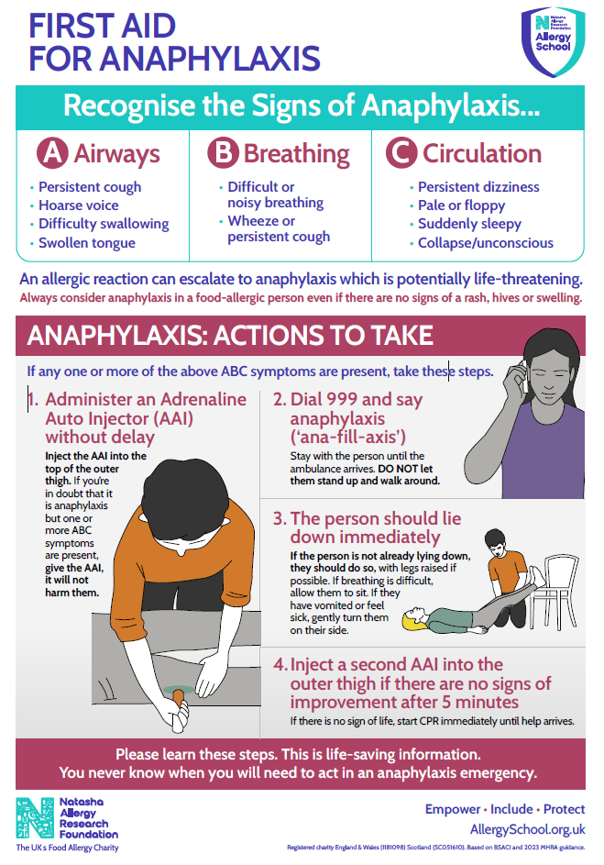

APPENDIX II

Epipen AAI and Jext AAI Instructions
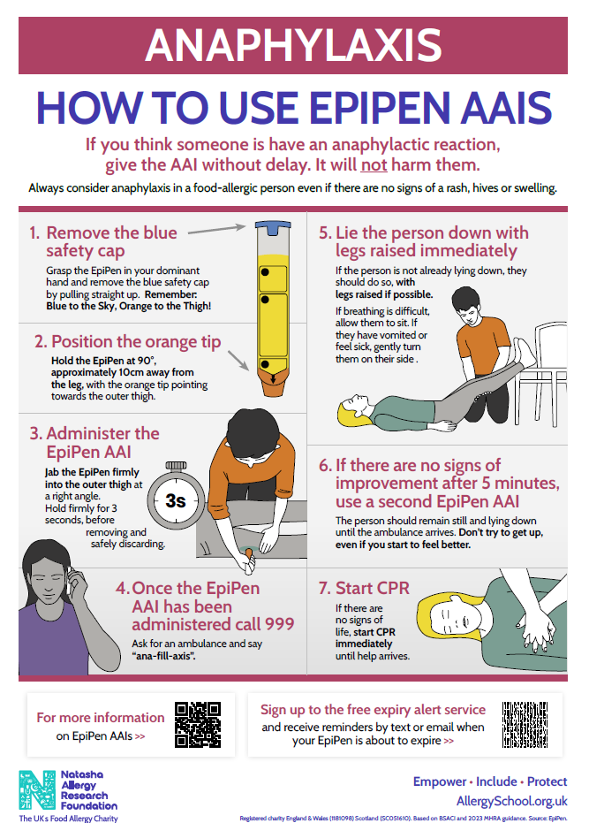

APPENDIX II

Epipen AAI and Jext AAI Instructions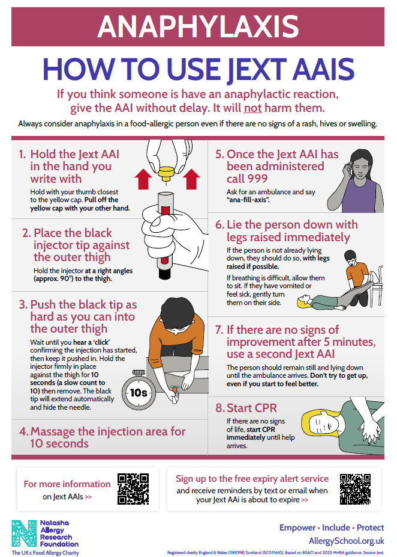
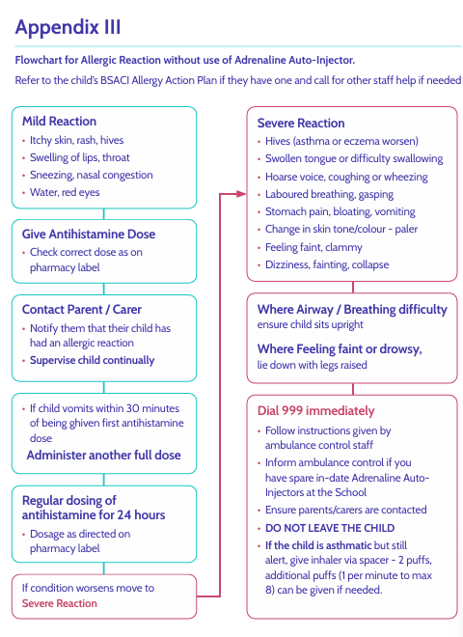
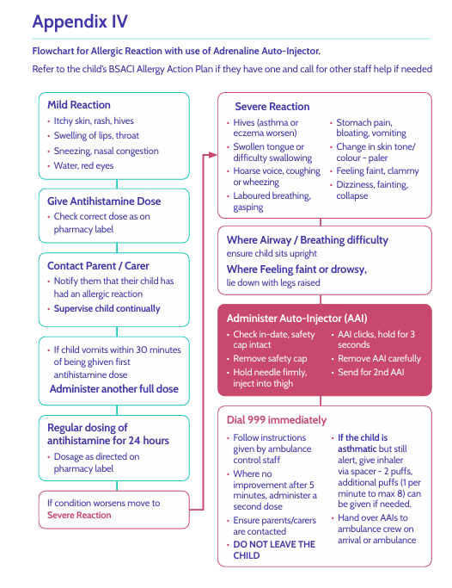

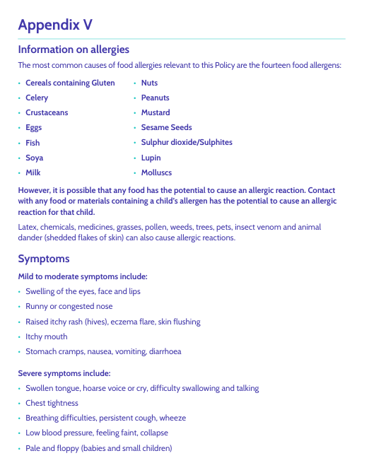

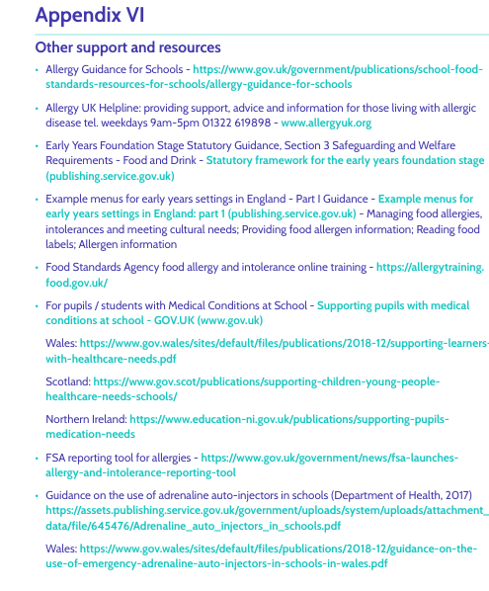
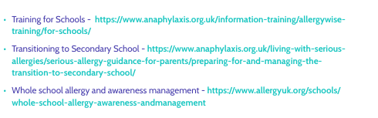
Appendix VII
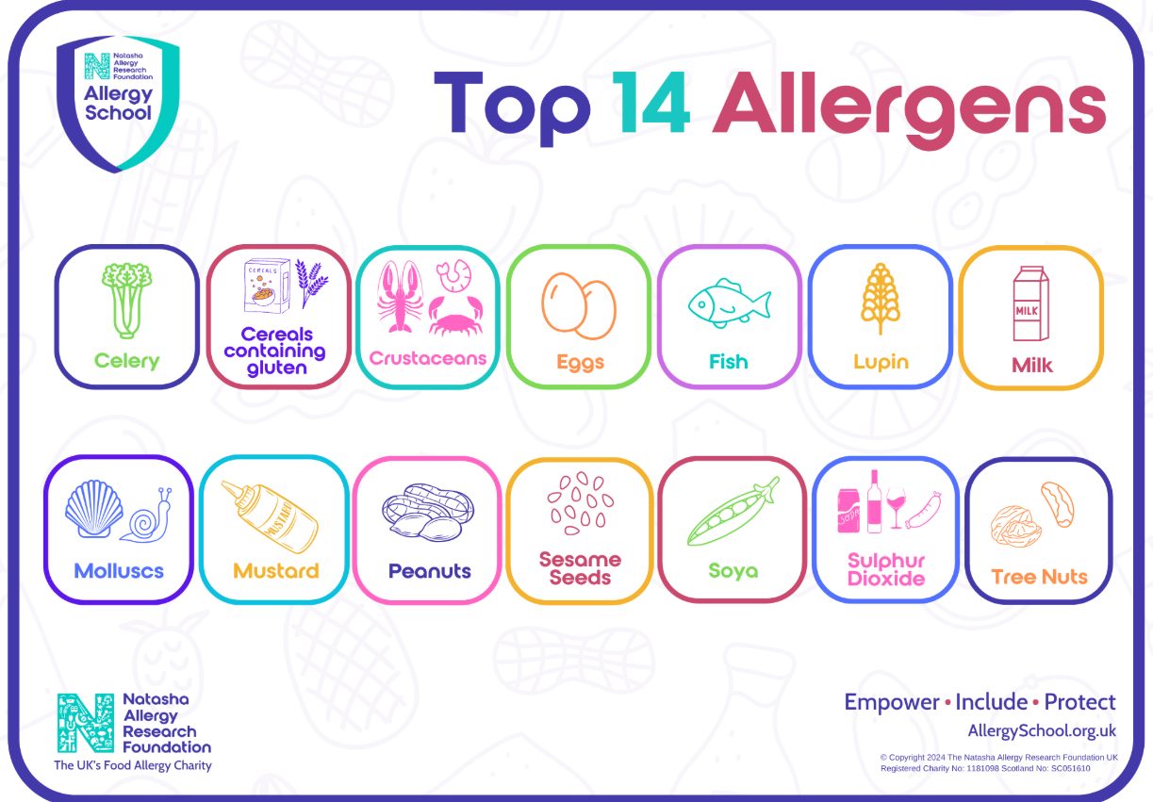

Appendix VIII – Aspens Alternative Menu Form



